**Myant Quick Instructions for Study Execution**

1. Measure the participant with a soft tape measure to determine the appropriate size of garment. For the chest band, measure the perimeter of the chest, in a relaxed state, horizontally, **one inch under the pectoral/breast fold at rest**. For the underwear, Measure the high hip circumference by finding the protruding points of the hip bones, approximately 3" below your natural waist.
2. Based on the measurement and the table below, select the band for the participant.
   1. If the person is just on the edge between two sizes, select the smaller one.
   2. If the person is out of the sizing chart, they should be excluded from the test.

| SKIIN Size | Size range based on underbust measurement | Womens Underwear  High hip circumference | Mens Underwear  High hip circumference |
| --- | --- | --- | --- |
| 2XS | 27 1/2" - 29 1/4" | - | - |
| XS | 29 1/2" - 31 1/2" | 29.25" - 32" | 30” - 32.5” |
| S | 31 3/4" - 33 3/4" | 32.25" - 34.20" | 32.75” - 35” |
| M | 34" - 36" | 34.75" - 37" | 35.25’ - 37.5” |
| L | 36 1/4" - 38 1/2" | 37.25" - 40.25" | 37.75’ - 41.5” |
| XL | 38 3/4" - 41 1/4" | 40.75" - 45" | 41.75’ - 45” |
| 2XL | 41 1/2” - 44 1/4” | - | - |
| 3XL | 44 1/2” - 47 1/2” | - | - |

1. The underwear is self-explanatory to wear but Help the participant put on the chest band.
   1. The band should be under chest level (about 1 inch under pectoral/breast fold line).
   2. The hooks should be at the front, vertically aligned under the right nipple.
   3. The vertical line knitted close to the enclosure should be medial, aligned with the center of the sternum.
   4. The front left electrodes should be under the left pectoral, but not in the gap under the sternum (the electrode should be entirely in contact with the skin)
   5. The two side electrodes should be symmetrically positioned on each side of the chest.
   6. The electrodes should be in contact with the skin and the module dock outward, vertically set and aligned under the left nipple (+- 1 inch).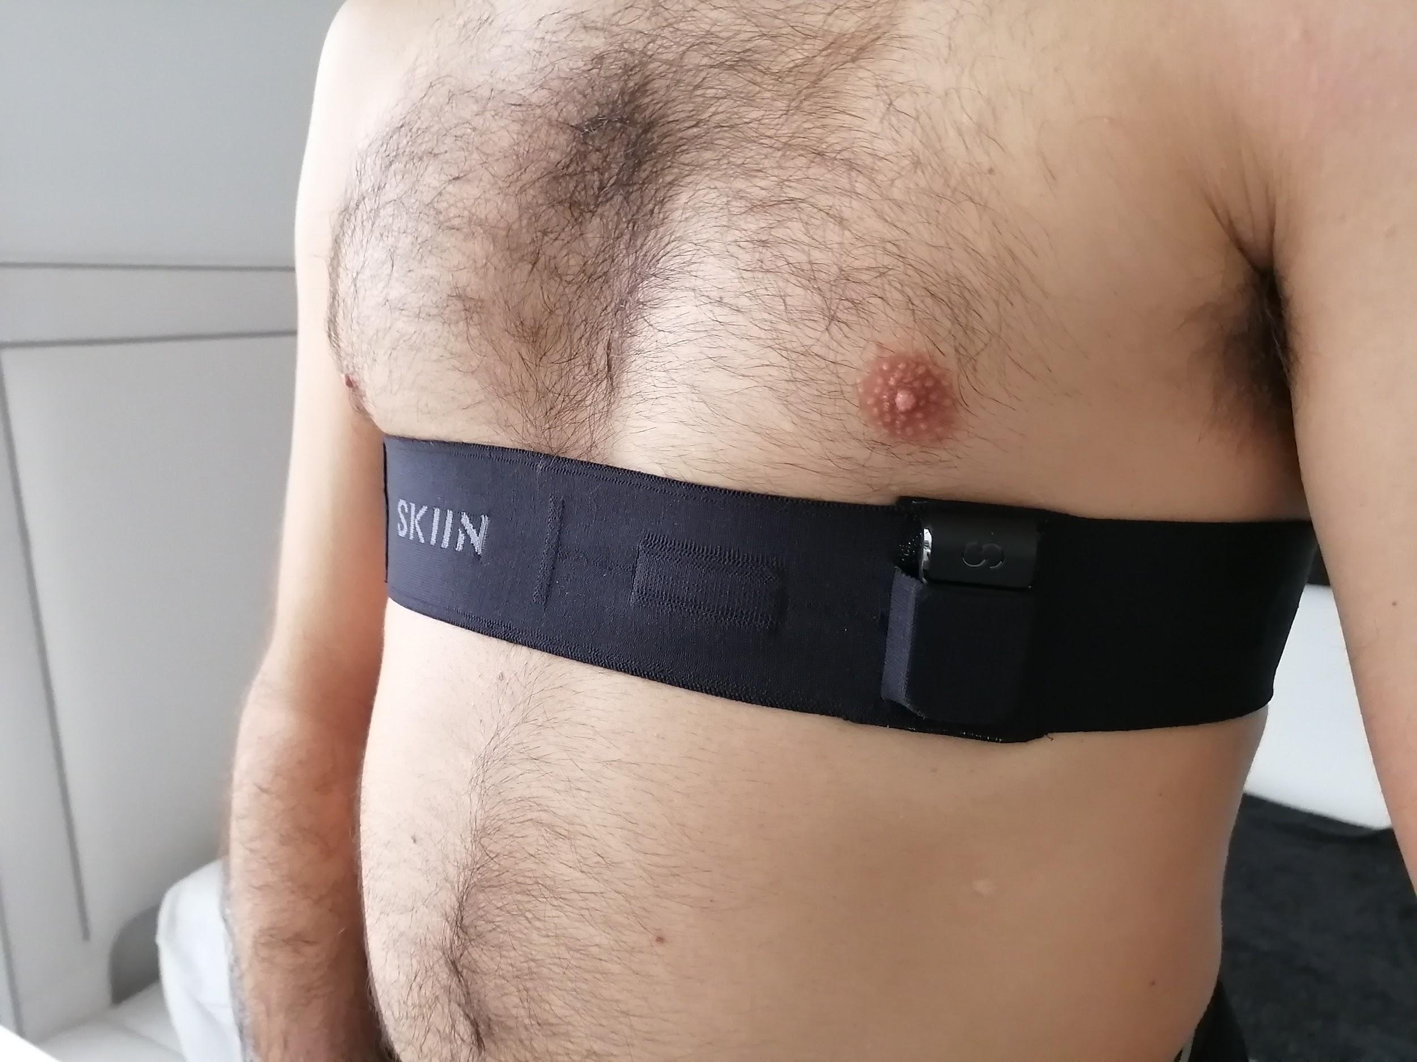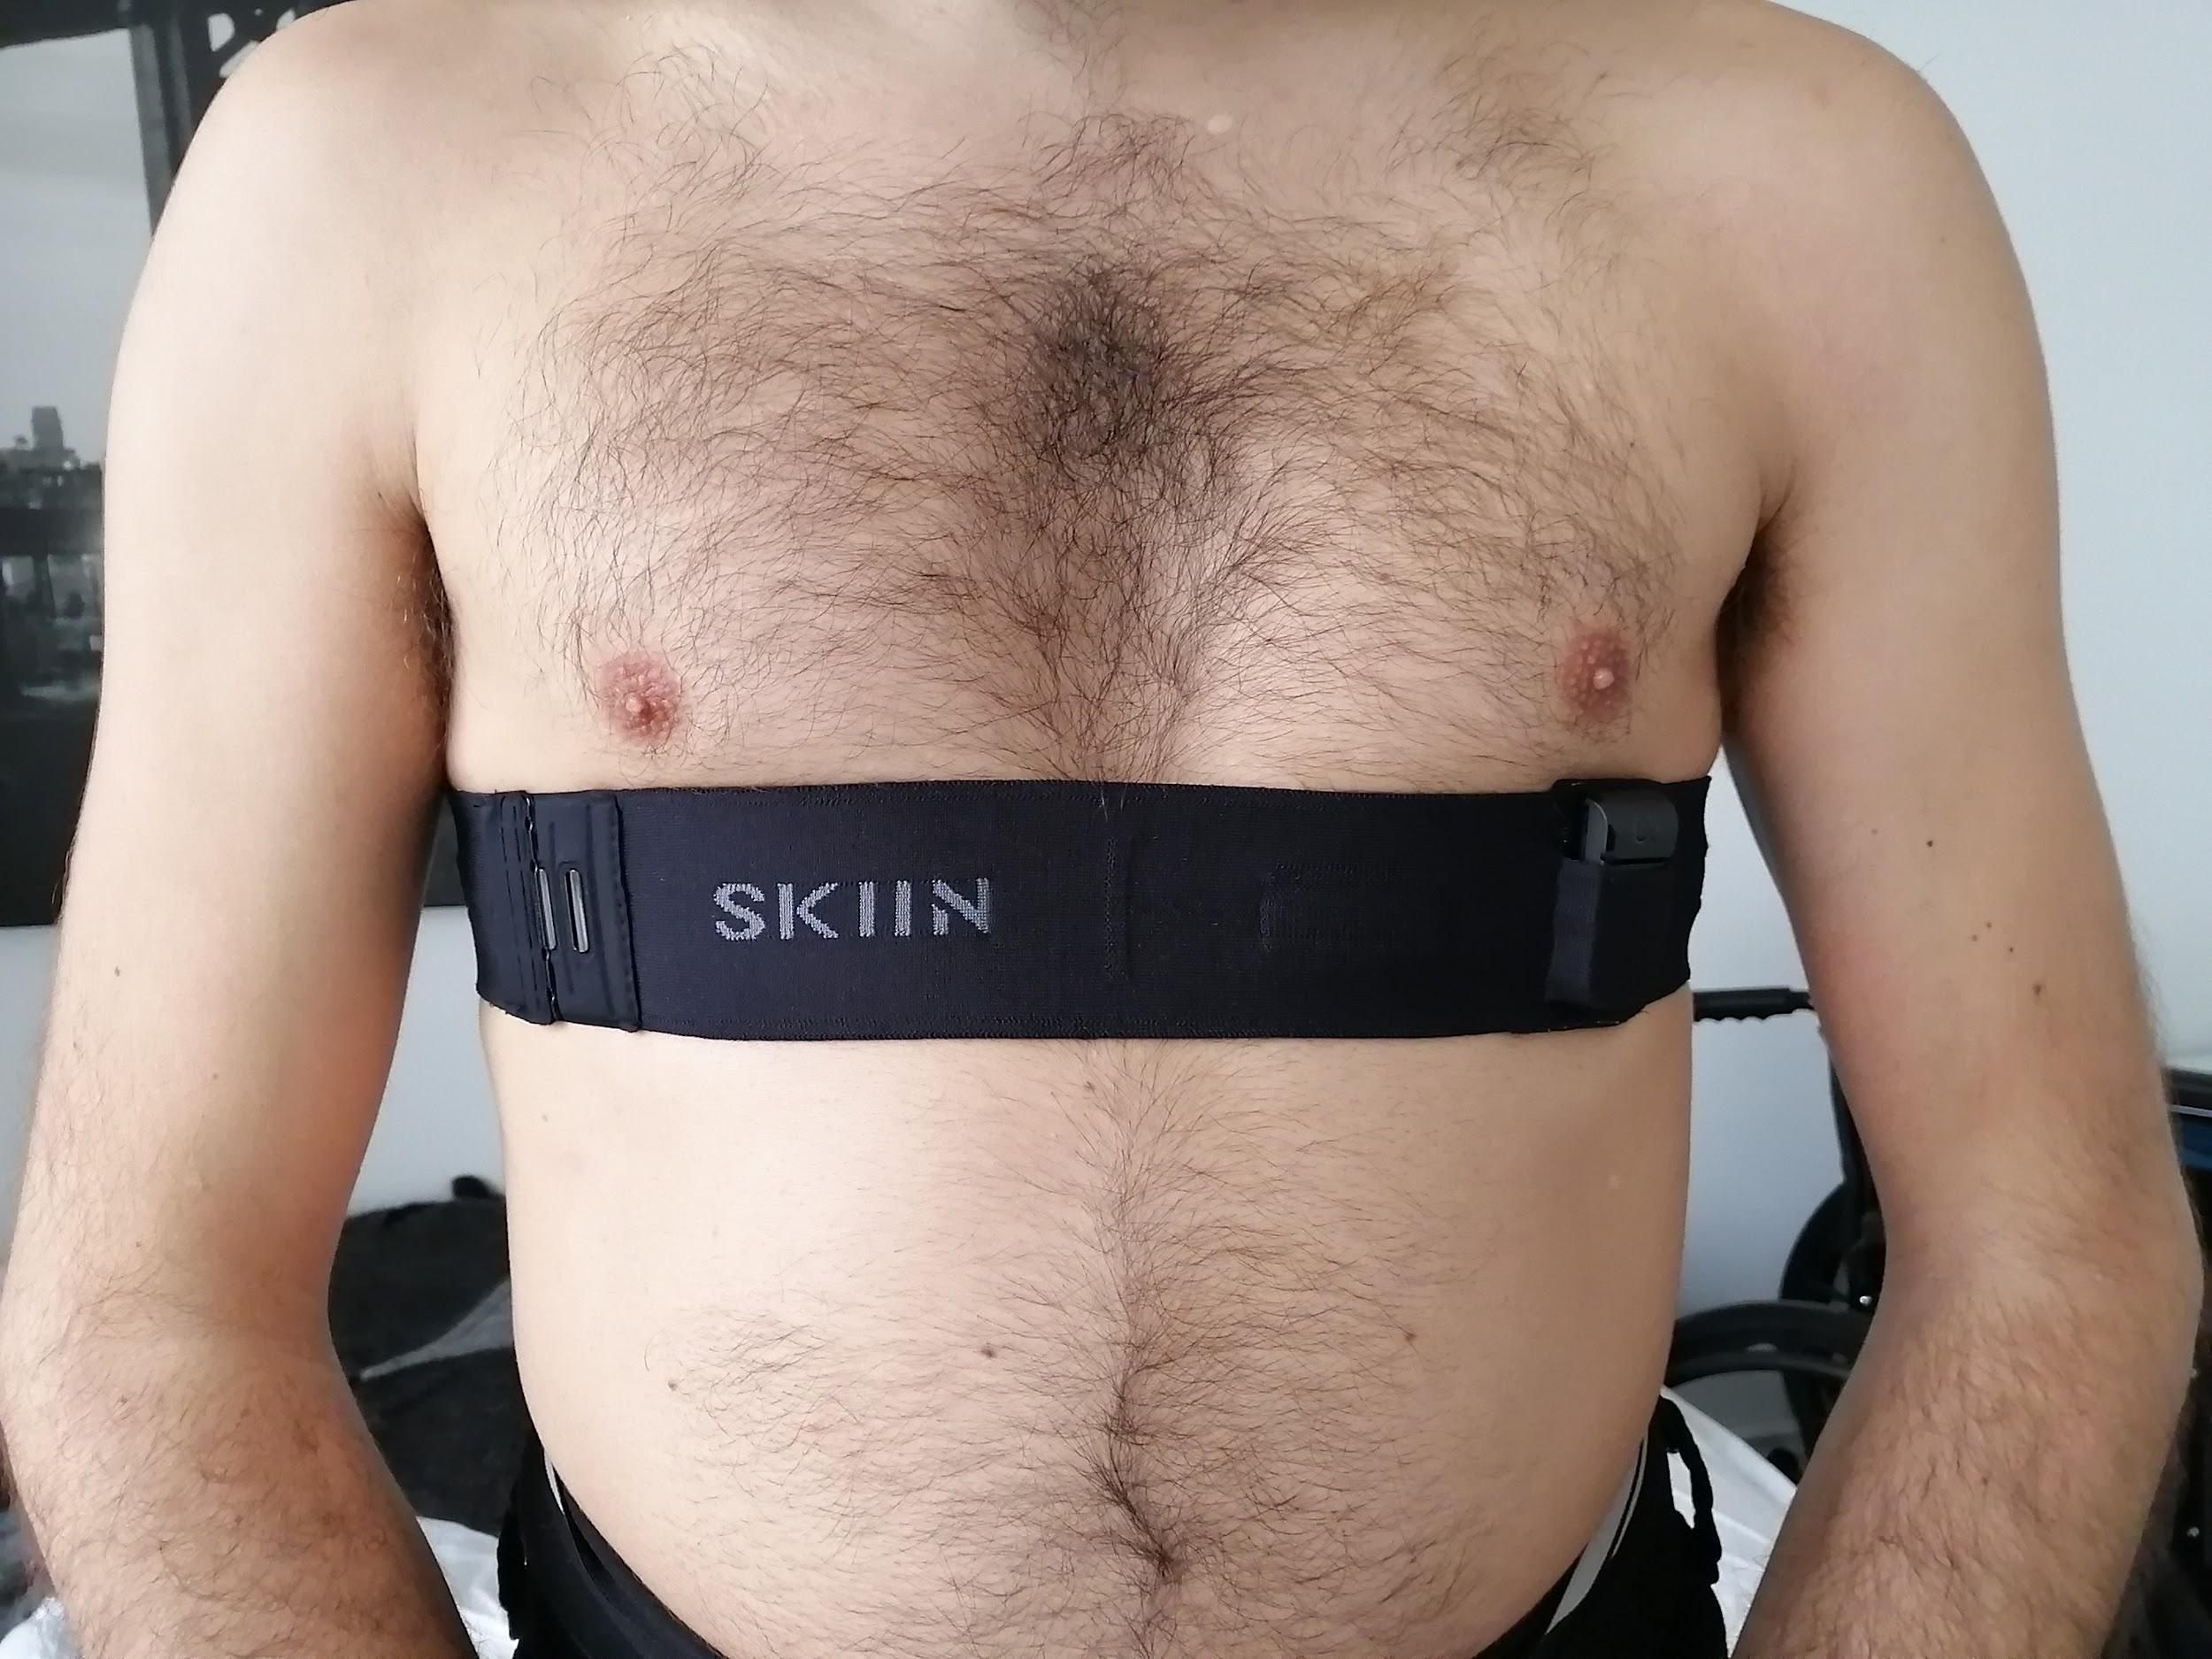
2. Have participants **apply moisturizer below each electrode (the raised fabric of the waistband of the underwear or chest band), by applying ½ teaspoon of moisturizer and rubbing it horizontally until there is no excess perceptible.** More can be added for those with larger circumferences and if the signal quality is bad.
3. Introduce the charged pod in the band
4. Verify with both system that the data can be streamed and visualized:
   1. For the **Myant DevTool App on Android Phone** (image below for reference, with corresponding numbers)
      1. On the phone home screen, select the **1. DevTool App**
      2. Select the button **2. Scan for Pods**. After a few seconds, a list of nearby devices will be populated. Each device is listed with the name (udw_afib) and the mac address (six pairs of characters separated by colon). On the module, the first pair of the mac address is written on the tape as (EVT - ##). Select the corresponding list entry on the app of the device required
         1. A pop up may show up to tell you to enable Bluetooth if it is not turned on. If this occurs, swipe down from the top of the phone screen, and press the Bluetooth symbol to enable.
      3. After a few seconds to connect to the module, the data page will show up. Click the grey boxes to enter details on how you want to save data.
         1. **Interval Box** : How many seconds to save before a file is saved (i.e if 10 is entered, each file will have 10 seconds of data)
         2. **Duration Box** : Total time of the recording (i.e if 200 is entered, 200 seconds of data will be saved, and the number of files created will be duration box/interval box)
         3. **File Name Includes Box** : This adds an identifier to the name of the saved file. The file names all have the date and time added as well, so no files will be overwritten. (i.e. if you enter SubjectID_Activity_Trial#, then the file names will be SubjectID_Activity_Trial#_macaddress_date_time.csv)
            1. **Note.** Use the File name box to identify the files for each subject
      4. Click the **4. Show Live ECG** button to confirm that ECG is being sent correctly from the device before beginning the recording. The ECG Graphtakes a few seconds to zoom and scale, and the buttons labelled ECG1, ECG2, and ECG3 can be used to switch the view to each channel.
      5. Click the **5. Start Saving Data** button to start the recording using the defined options.
         1. *The reference system should be started at the same time as the Skiin system.*
         2. *In order to synchronize the two ECG systems, triple tap the textile and the gel electrode at the same time.*
      6. Confirm that the app indicates that it is still recording. If doing a longer period test, occasionally check this to ensure that the app has not disconnected.
      7. When the recording is done, transfer the files using one of these methods:
         1. **Email from Phone** - From the home phone page, select **7. Files** and navigate to the **8. *Downloads* Folder.** Find the relevant files that should be labelled as you defined in the File Name Box (Step 3). Long press one of the files, then single press each of the other files (if applicable). Select the “Share” icon in the top right corner of the screen, and email using gmail. You may need to log into your gmail account to do so
         2. **Transfer to Computer -** Plug the phone into your computer using any microUSB cable. On the computer, navigate to **9. This PC** to view the Drives on the computer. Select the **Phone/tablet > Downloads** folder, find the relevant files that should be labelled as you defined in the File Name Box (Step 3), and move them into a separate folder as per **Step 17.** 
            1. **Note:** If the device is not there, swipe down from the top of the phone screen, and select the **USB charging this device** icon. Then select the **Transfer files** check box. If these options are also not available, try another USB cable.

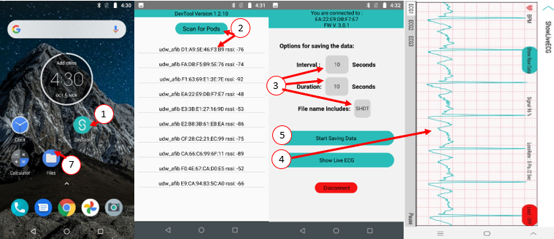

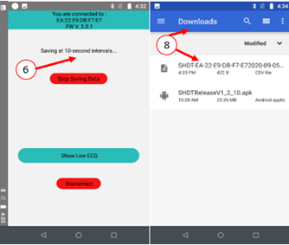

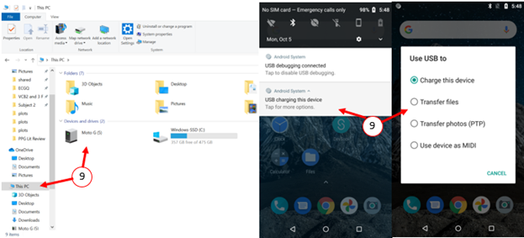

1. Save all files in a **Myant study** folder on the Windows Desktop, in a *new folder* identifying the Participant ID and the Date.
2. Reconnect the pod to the charging dock (connected to a computer or to power) to reload its battery.

**Note:** if the app doesn’t operate as usual or as described above, close it, then reopen it after a few seconds. If it was an issue of connectivity between the app and the pod, it may help to disable and re-enable the Bluetooth of the device before reopening the app.